****

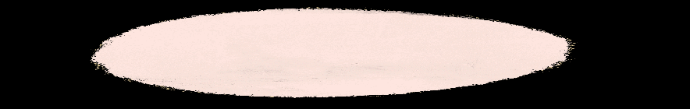**name: class: date:**

D:\02_Lehrermarktplatz\Cliparts_LITTLECLIPARTFACTORY\doodles\Schulfächer Doodles\Englisch.png

***CHECKLIST***

*1.) Watch your tutorial very carefully.*

|  |  |
| --- | --- |
|  | **✓** |
| **technical things** | |
| The tutorial has got a **title. It is \_\_\_\_\_\_\_\_\_\_\_\_\_\_\_\_\_\_\_\_\_\_\_\_\_\_\_\_\_\_\_\_\_\_\_\_\_\_\_\_\_\_\_\_\_\_\_\_\_\_\_\_\_\_ .** |  |
| The **sound quality** is OK. |  |
| The **image quality** is OK. |  |
| The **background** of the tutorial is not distracting (ablenkend). |  |
| **the content** | |
| I know who **made the tutorial.** |  |
| **I know what this video is about.** |  |
| There is a **greeting at the start** of the video.  It says: |  |
| There is an **outro at the end** of the video.  It says: |  |
| There is a **reference list** (Quellenangabe) at the end  or in the description of the video. |  |
| **the speaker** | |
| The speaker explains **slowly or in a normal speaking tempo**. |  |
| The speaker talks **clearly** and **pronounces** every word correct. |  |
| The speaker talks in a good **speech volume** (Sprechlautstärke) |  |
| **spelling and words** | |
| There are **no spelling mistakes**. |  |
| The **sentences** are **build** correctly. |  |
| There are **suitable words** to explain everything. (correct vocabulary) |  |

**Can you find all these content in your tutorial? 🗹 Tick** the checklist!

***2.) Watch your tutorial again and circle which smiley matches best.***

***After that talk to your group, listen what they say about their tutorial and circle their answers too.***



\_\_\_\_\_\_ 👍likes and \_\_\_\_\_\_\_\_views

\_\_\_\_\_\_ 👍likes and \_\_\_\_\_\_\_\_views

\_\_\_\_\_\_ 👍likes and \_\_\_\_\_\_\_\_views

**my tutorial has got...**

**this tutorial has got...**

**this tutorial has got...**

🞏 interesting 🞏 boring

🞏 motivating 🞏 \_\_\_\_\_\_\_\_\_\_\_\_\_\_\_

🞏 interesting 🞏 boring

🞏 motivating 🞏 \_\_\_\_\_\_\_\_\_\_\_\_\_\_\_

**This tutorial is ...**

**This tutorial is ...**

🞏 interesting 🞏 boring

🞏 motivating 🞏 \_\_\_\_\_\_\_\_\_\_\_\_\_\_\_

**my tutorial is ...**

**language**

**length**

*of the video*

**used images**

*in the video*

**language**

**length**

*of the video*

**used images**

*in the video*

**language**

**length**

*of the video*

**used images**

*in the video*

**my tutorial is ...**

🞏 an animated video

🞏a screencast

🞏 a instructor-led tutorial

🞏 a „Legevideo“

🞏 animated video

🞏 screencast

🞏 instructor-led tutorial

🞏 „Legevideo“

🞏 animated video

🞏 screencast

🞏 instructor-led tutorial

🞏 „Legevideo“

*title of the tutorial:*

*title of the tutorial:*